6G Spectrum Analyzer device

User manual

CONTENT
1 SUMMARY 1
1.1 introduction 1
2 DELIVERY LIST 1
3 SPECIFICATIONS 1
4 NOTICES 2
5 COMPOSITION OF THE DEVICE 4
5.1 The composition of the device is shown in Figure 5.1 4
5.2 The block of buttons for controlling the device is shown in Figure 5.2 4
6 URNING ON/OFF 5
6.1 Turning on the device 5
6.2 Turning off the device 5
7 THE SCREEN OF THE DEVICE 6
7.1 Screen grid and information label 6
7.2 Main menu 7
7.3 Setting the frequency range of the analyzed signal 7
7.4 Setting the main parameters of the amplitude of the analyzed signal 9
7.5 Menu for setting markers and signal peaks 10
7.6 Signal generator frequency and power setting menu 13
7.7 Setting parameters and measuring the reflection coefficient S11 16
7.8 Setting parameters and measuring the standing wave ratio SWR 19
7.9 Custom settings menu 21

SUMMARY

introduction
1.1. Portable spectrum analyzers are designed to display the spectrums of signals in the frequency range 35-6200 MHz.
1.2. The device is designed to determine the amplitude and frequency of the spectral components included in the signal.
1.3. The presence of a built-in signal generator allows you to measure the magnitude-frequency characteristics of active / passive devices (amplifiers, repeaters, filters) and measure reflections / standing wave ratio (SWR).
1.4. The device is designed to work in the range of ambient temperatures from 0 to +50 °С and relative
air humidity not more than 75%.
1.5. The analyzer is not intended:
- to work in open areas during snow or rain;
- in places with a corrosive or explosive environment (dust, steam, gas);
- for use by people (including children) who have physical, nervous or mental abnormalities or lack of experience and knowledge that impede the safe operation of the device without supervision or training;
- use by children for games.

DELIVERY LIST
Table 1
Name | Quantity
Spectrum analyzer | 1 pcs
Connecting cable USB Type-C | 1 pcs
Touch pen | 1 pcs
SMA RG174 RF cable 30cm | 2 pcs
SMA KK female connector | 1 pcs

SPECIFICATIONS

Table 2
Parameter name |  | Value
Displayed frequency range |  | 35-6200 MHz
Measured frequency range |  | 35-4500 MHz
Dynamic range | for 35-3000 MHz band | 75 dB
Dynamic range | for 3000-4500 MHz band | 70 dB
Maximum bandwidth |  | 6165 MHz
IF bandwidth (fixed) |  | 200 kHz
Sweep speed with a span of more than 100 MHz |  | 700 MHz/s
Sweep time of 100 MHz span |  | < 0.25 s
Detectable signal duration at 10 MHz scan span |  | 20 ms
Noise floor | in the band up to 3000 MHz | < -100 dBm
Noise floor | in the band 3000-4500 MHz | < -95 dBm
Noise floor | in the band 4500-6200 MHz | < -90 dBm
Input impedance |  | 50 Ohm
SWR in the operating frequency range |  | < 1,5
Internal attenuator |  | 0-30 dB
Error of attenuation  up to 10 dB | 2 dB
Error of attenuation  up to 10 dB | from 10 to 20 dB | 5 dB
Error of attenuation  up to 10 dB | from 20 to 30 dB | 8 dB
Frequency range of built-in tracking generator |  | 35-6200 MHz
Tracking generator output power |  | -15 .. -25 dBm
Accuracy of display of a signal within a dynamic range |  | 2 dB
Maximum input power | with 0 dB attenuator | + 10 dBm
Maximum input power | with attenuator > 20 dB | + 20 dBm
The measured maximum input signal |  | + 10 dBm
Maximum RF input DC voltage |  | 25 V
Maximum supply current | when running on battery | 450 mA
Maximum supply current | when running on USB  (in charging mode) | 500 mA
Battery capacity |  | 3000 mAh
Continuous operation time from accumulator |  | 3 h
Battery charging time |  | ~5 h
Dimensions |  | 155×81×27 mm
Weight |  | 0.49kg

NOTICES
4.1. General safety requirements
4.1.1. To work with the instrument allowed persons familiar with the present "User Manual" and been briefed on rules for safe work with electrical appliances.
4.1.2. The risk of injury is possible when the charger is plugged in or unplugged. Use serviceable sockets and chargers.
4.1.3. In order to avoid damage to the wires and connectors of the device, it is prohibited to hang anything on the wires, paint over and glue the wires and connectors, disconnect the wires from the cord.
4.1.4. It is strictly forbidden to persons using the device: transfer the device to strangers, disassemble and repair any device not agreed with the manufacturer, use the device with a damaged case.
4.1.5. If a fault is detected, stop operation immediately and turn off the instrument.
4.1.6. If you need to leave the workplace, turn off the device and other devices. Do not leave the device running unattended!
4.1.7. Do not use the device in hospitals. The use of the device near medical equipment is allowed only with the consent of the medical staff.
4.2. Additional security requirements
4.2.1. Use the device only for its intended purpose. Familiarize yourself with the purpose, device and technical characteristics of the device.
4.2.2. Keep the balance and steady posture while working with the device. Move slowly, do not run.
4.2.3. Avoid working in open spaces during snow or rain. Increased humidity and all types of liquid, once inside the device, can damage it.
4.2.4. Do not expose the device to very low or very high temperatures; exposure to extreme tempera
tures may damage the internal battery.
4.2.5. Do not use the appliance in a corrosive or explosive environment. Aggressive vapors can destroy the insulation, which can lead to failure of the device.
4.2.6. Do not carry the device by the cables and wires connected to it, do not unplug the connectors by pulling the cable or cord.
4.2.7. Do not apply excessive force to the control buttons and the instrument screen.
4.2.8. Avoid dropping or otherwise shocking the unit. The device may be damaged if dropped.
4.2.9. Do not disassemble or modify the appliance without the approval of the manufacturer or outside of the procedures described in this manual. Incorrect self-intervention will result in loss of warranty.
4.2.10. Do not allow children to play with the device, as they can hurt or injure others, or damage the device.
4.2.11. Use chargers, cords, adapters and other accessories recommended by the manufacturer.
4.2.12. When connecting to the device other devices, carefully read their purpose, technical characteristics and safety rules in their manuals. Do not connect incompatible devices.
4.2.13. Maintenance and repair of the instrument must be carried out only by the manufacturer or an authorized service center.

Notice：We are not responsible for the damage of the machine caused by privately upgrading the software version.

COMPOSITION OF THE DEVICE

The composition of the device is shown in Figure 5.1
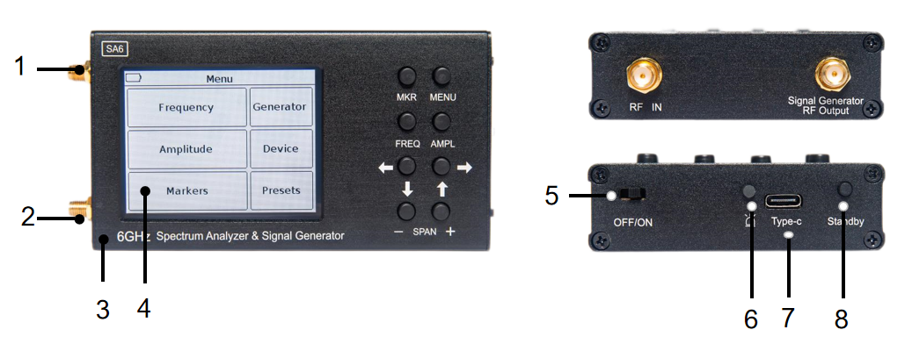
Figure 5.1 External view of the device
1.The output of the signal generator TG OUT;
2.Antenna input RF IN;
3.Housing;
4.Colour resistive screen of 3.2” ;
5.OFF/ON;
6.Battery charge indicator charge;
7.Connector type C USB;
8.Standby button on/off .

The block of buttons for controlling the device is shown in Figure 5.2
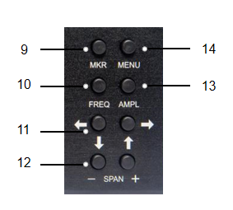
Figure 5.2 Control buttons unit

9.«MKR» setting markers. Long (more than 2 seconds) button holding opens the menu of markers and peak values of the analyzed signal.
10.«FREQ»-displays the frequency parameters on the screen. Long press (more than 2 seconds) to open the menu for setting the viewing frequency range.
11. Buttons to move the screen scale grid and change the frequency.
12.«SPAN»(overview frequency range) -buttons " -" and " + " change the frequency range of the analyzed signal.
13.«AMPL»-output amplitude parameters on the screen. Long (more than 2 seconds) holding the button opens the menu for setting the amplitude parameters.
14.«MENU»-the button opens the main menu of the device.

URNING ON/OFF

Turning on the device
Power on: when the device is off, turn on the side switch button, and then press the menu button for more than 2 seconds to turn on the device. The screen will display the results of the device self-test. Then, the device switches to normal operation.

Turning off the device
Power off: when the device is running, long press the menu button for more than 2 seconds. After the screen goes out, turn off the side switch button.

THE SCREEN OF THE DEVICE
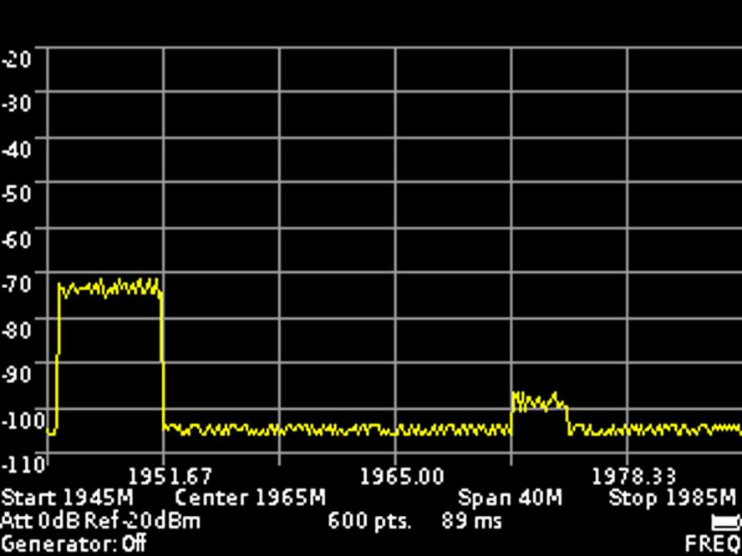
Figure 5- Grid and information on the screen

Screen grid and information label
7.1.1. The screen of the device is divided by a scale grid consisting of horizontal and vertical lines. The horizontal axis is calibrated with a frequency that increases linearly from left to right. The vertical axis is calibrated in amplitude. A logarithmic scale is set, calibrated either in decibels per milliwatt (dBm) or in decibels per microvolt (dBuV).
7.1.2. At the bottom of the screen is an information label, which displays the current settings of the device and the parameters of the frequency range of the review, the analyzed signal.
For example, in figure 5, the initial frequency of the test signal «Start» is 1945 MHz, the final frequency «Stop» is 1985 MHz. Survey range frequency «Span» is 40 MHz, the сentral frequency «Center» is 1965 MHz. Internal attenuator «Att» is set to 0 dB, the maximum level of the input harmonic signal «Ref» is set at the level of -20 dBm, a built-in signal generator the «Generator» is disabled (Off) . Also displayed on the screen: the number of scan points «pts» and the scan time in milliseconds «ms». In the lower right corner displays the degree of discharge of the battery.
7.1.3. To move the screen scale grid up and down (in amplitude), briefly press the «AMPL» on the button block. «AMPL» appears in the lower right corner of the screen. Use the navigation to move the screen grid up and down.
7.1.4. To move the scale grid of the screen left-right (in frequency), briefly press the «FREQ» on the button block. «FREQ» appears in the lower right corner of the screen. Use the navigation to move the screen grid left-right.
Note. When moving the scale grid left-right (in frequency), the specified span of the frequency «Span» does not change. The values of the initial «Start», the final «Stop» and the central «Center» frequencies of the measured signal change.
7.1.5. To move the markers (left-right) in frequency, briefly press the «MKR» on the block of buttons. In the lower right corner of the screen appears the inscription «MK 1» (the number is the ordinal number of the marker). Use the navigation to change the position of the marker. If there are more than one markers, then to switch between them, briefly press the «MKR» button. The designation of the active marker (MK 1 ... MK 4) will appear in the lower right corner of the screen. In the upper left corner of the screen information will appear on the signal power of the marked frequency.

Main menu
7.2.1. Turn on the instrument in accordance with section 6 of this «Manual». To enter the main menu, press the «MENU» on the button block. The menu appears on the screen, as in figure 6.
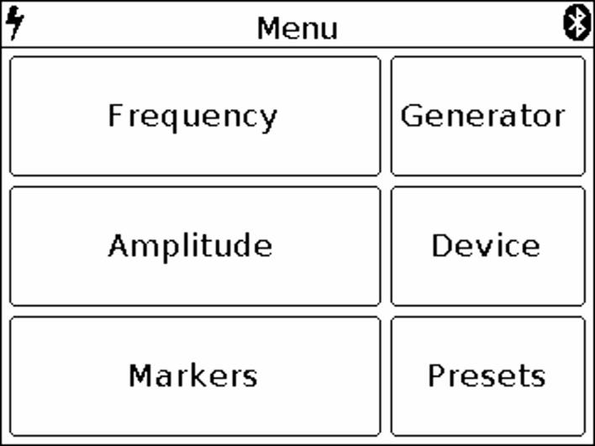
Figure 6 – Main menu

7.2.2. Each section of the main menu has its own purpose:
Frequency - subsection of the menu in which the frequency range of the analyzed signal is set.
Amplitude – the subsection of the menu in which the amplitude parameters are set (step and scale of the screen grid, input resistance, maximum level of the input harmonic signal).
Markers – a submenu in which visual amplitude markers are set at a fixed frequency or over the entire frequency range of the analyzed signal.
Generator – the menu for turning on the signal generator, setting the power and frequency of the signal generator. It also measures the standing wave ratio (SWR) and the amplitude-frequency response of the equipment under test.
Device - in this menu, the device shutdown timer, amplitude and frequency shift are set, the serial number of the device, its version and the settings for connecting the device via Bluetooth are specified.
Presets - menu to save custom presets.
7.2.3. To exit the main menu, press «MENU».

Setting the frequency range of the analyzed signal

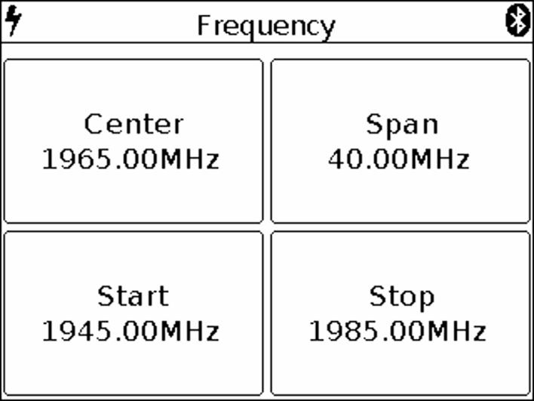
Figure 7 – Menu of setting the frequency of the overview

7.3.1. To set the frequency range, enter the main menu of the instrument (Figure 6) by pressing «MENU». Select subsection «Frequency». The menu appears on the screen, as in figure 7.
Note. For quick access to the menu, press and hold the for about 2 seconds «FREQ».
7.3.2. Each of the options of the submenu has its own purpose:
Center – setting the center frequency of the frequency range of the overview of the analyzed signal.
Span – setting the frequency range.
Start – setting the initial frequency of the measured frequency range.
Stop - setting the final frequency of the measured frequency range.
7.3.3. Each of the parameters is set by entering a numerical value in the opened submenu, as in Figure 8. Enter the numeric value of the frequencies and press Enter. To delete erroneous or previously entered values, press Del. To refuse to enter a value, press Cancel. In our example, in Figure 8, setting the frequency range of the survey is 40 MHz wide.

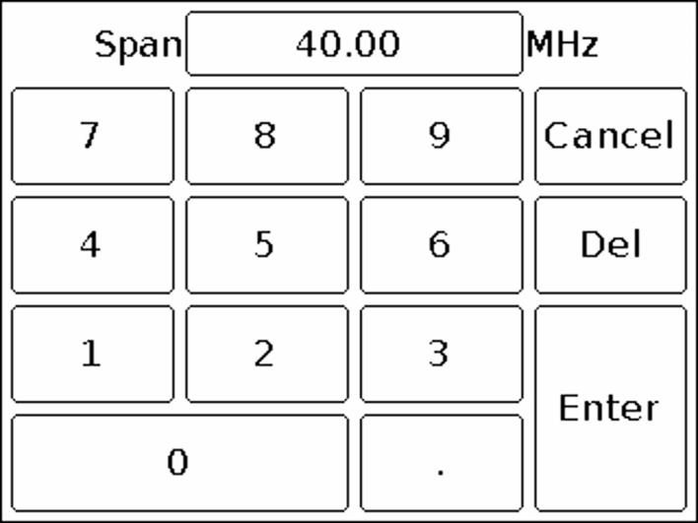
Figure 8 – Entering numerical values

7.3.4. In the analysis of wide frequency ranges (Span) more than 40 MHz, to reduce the analysis time, the frequency scan is performed with a maximum step. In this case, the error in measuring the signal power can reach 6 dB. This mode is used for rapid detection of signals and is not intended for accurate power measurements. To increase the measurement accuracy to 3 dB, it is necessary to reduce the width of the span to values less than 40 MHz. Further reduction of the span will lead to a decrease in measurement error.
7.3.5. Setting the frequency parameters in three ways:
a) By entering the initial Start and final Stop frequencies, the center Central frequency is automatically assumed to be equal to their half-sum. The frequency range of the overview Span is automatically taken equal to the difference between the final and initial frequencies.
b) Setting the center frequency Center and the frequency range of the overview Span. In this case, the initial Start and final Stop frequencies will be set automatically, as Center ± Span / 2.
c) By loading custom settings from the Presets menu.
7.3.6. To exit the menu of setting the frequency range to the main menu, press the «MENU».

Setting the main parameters of the amplitude of the analyzed signal
7.4.1. To set the amplitude parameters of the analyzed signals, enter the main menu of the device (figure 6) by pressing the «MENU». Select the subsection Amplitude. The menu will appear on the screen, as in Figure 9.
Note. For quick access to the menu, press and hold the «AMPL» for about 2 seconds.

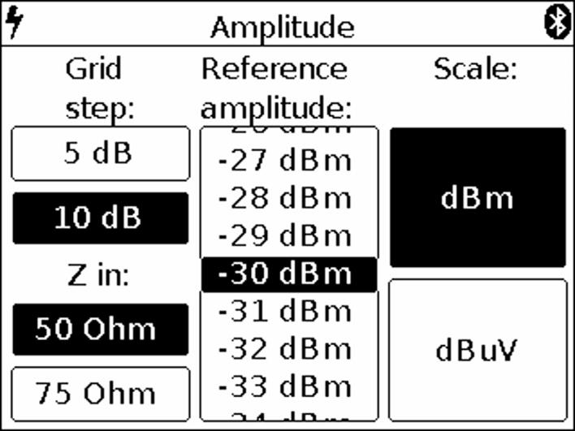
Figure 9 – Amplitude parameters setup menu

7.4.2. In this menu, the following parameters are set:
Grid step – parameter that sets the step of the scale grid of the screen, along the vertical axis. It is possible to set the grid in increments of 5 dB or 10 dB.
Z in – The parameter that determines the input / output impedance. It is used when calculating the input signal level of the receiver and the generator output signal (if any). At the same time, the real value of impedances is 50 Ohm The value of 50 or 75 Ohm must be chosen depending on the wave impedance of the connected antenna / load.
Scale – change of vertical scale graduation in dBm or dBuV values.
Reference amplitude – the parameter that sets the maximum level of the input harmonic signal does not cause overload of the receiver (the maximum displayed value of the amplitude). It is set depending on the selected parameter calibration of the vertical scale (Scale) range from 10 to -75 dBm or in the range of 117 to 32 dBuV.
7.4.3. Each parameter is set by pressing the corresponding menu value or by "scrolling" the values to a fixed selected area.
7.4.4. The level of attenuation of the input signal (the value of the internal attenuator) is set automatically, depending on the set value Reference amplitude.
Attention! If the input signal level is much higher than the Reference amplitude value, a warning message Dynamic range exceeded appears on the device screen. In this case, the correct display of the input signal level is impossible. In this case it is necessary:
• increase the value Reference amplitude (the internal attenuator will be activated);
• to use an external attenuator.
7.4.5. To exit to the main menu, press the «MENU».

Menu for setting markers and signal peaks
7.5.1. To enter the menu of setting markers and peaks, enter the main menu of the device (Figure 6) by pressing the «MENU». Select subsection Markers. The menu appears on the instrument screen, as in Figure 10.
Note. To quickly access the menu, press and hold the button for about 2 seconds «MKR».
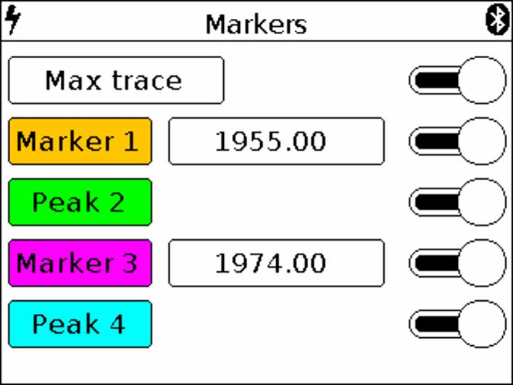
Figure 10 – The menu of markers and peak values of the signal. Max trace mode is on

7.5.2. In this menu are installed:
Max trace – when this mode is enabled, the maximum values of the signal are displayed on the screen and a red line is drawn along the points of the maximum values. In order to fix the track include a pause, touching the screen of the device.
Min trace – when this mode is enabled, the minimum values of the signal are displayed on the screen and a green line is drawn along the points of the minimum values. In order to fix the track include a pause, touching the screen of the device.
When you turn on the Avg trace (Average) mode, the signal will be averaged on the screen. The number of measurements in this mode is limited in the range from 4 to 16. In order to fix the track include a pause, touching the screen of the device.
In Waterfall mode, a spectrogram is displayed below the spectrum graph. The spectrogram allows you to analyze the background of the signal for a certain time interval. Due to the selectivity of color perception of a person, it is possible to detect signals at the noise level with the help of spectrogram.
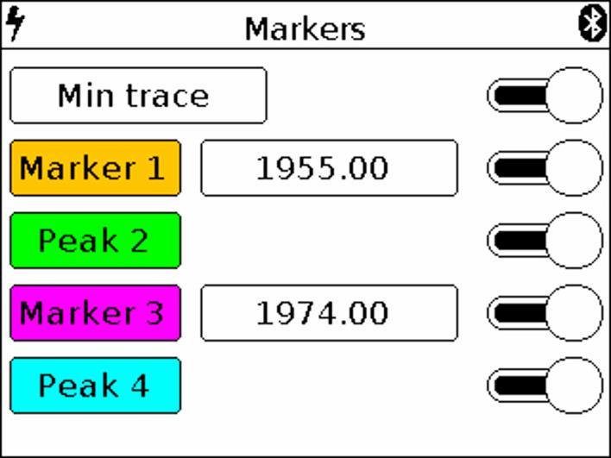
Figure 10.1 The menu of markers and peak values of the signal. Min trace mode is on

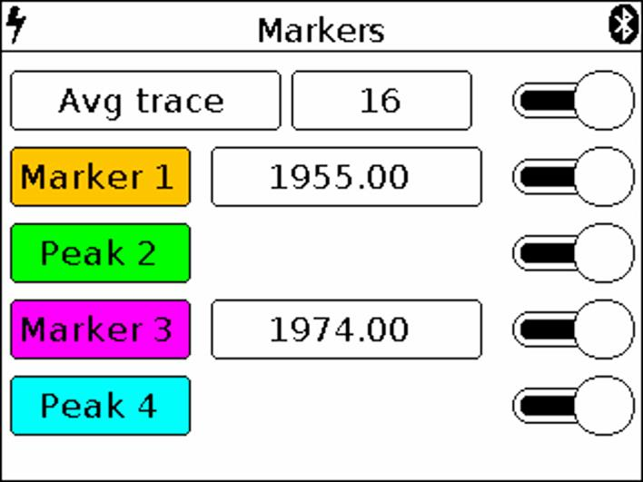
Figure 10.2 The menu of markers and peak values of the signal. Avg trace mode is on

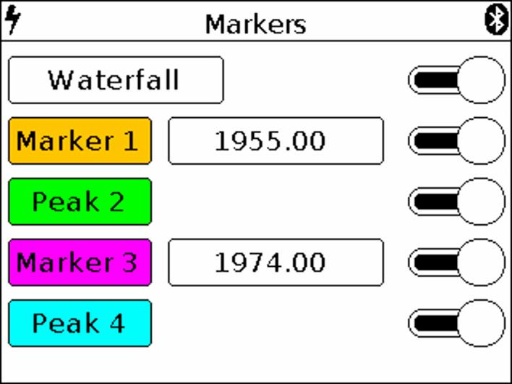
Figure 11 The menu of markers and peak values of the signal. Waterfall mode is on
When Waterfall mode is enabled, a spectrogram is displayed on the instrument screen below the spectrum graph (figure 11.1)
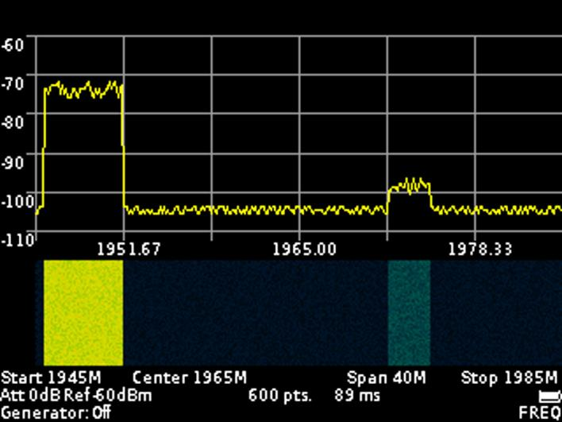
Figure 11.1 – Displaying the spectrogram below the spectrum graph
Turning on / off the Max trace, Min trace, Avg trace and Waterfall modes is performed by moving the “slider” to the right / left opposite the corresponding mode.
Marker - visual indicator of signal amplitude at the frequency of marker location specified by the operator. The design of the device allows the use of up to four multi-colored markers at the same time to monitor the change in the amplitudes of the analyzed signal at four frequencies given by the operator.
Note. Also, the marker can be switched to the maximum signal tracking mode (Peak mode). Up to four simultaneous tracking peaks on a chart.
Peak – visual indicator of the maximum value of the signal amplitude over the entire frequency range.
The design of the device allows the use of up to four multi-colored peak indicators to monitor changes in the amplitudes of the analyzed signal over the entire range of the specified frequency range.
7.5.3. Setting the specified marker frequency is performed by entering a numeric value in the opened submenu, as in figure 12. Enter a numeric frequency value and press Enter (enter data). To delete erroneous or previously entered values, press Del (Delete). To refuse to enter a value, click Cancel. In our example, in figure 12, we set the frequency to 1960 MHz for marker.
7.5.4. Moving the included markers on the screen in real time, make in accordance with paragraph 7.1.5. of this «Manual».
7.5.5. If it is necessary to search and track the maximum (peak) amplitude values over the entire range of the signal under analyze, one or several Marker indicators must be switched to the Peak value as shown in figure 10.
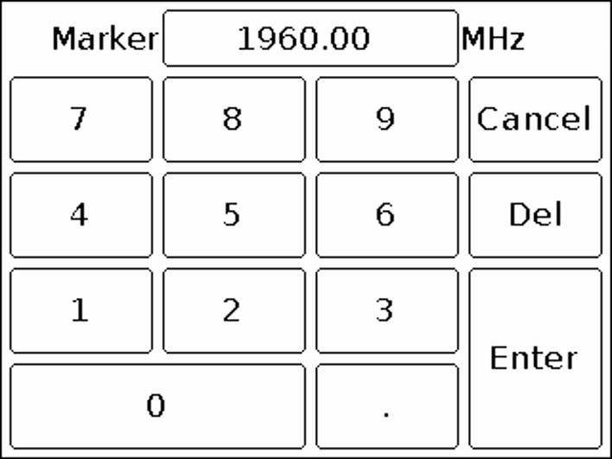
Figure 12 Entering numerical values of marker frequencies
Switching on / off the Marker and Peak modes is made by moving the “slider” to the right / left opposite the corresponding mode.
7.5.6. To exit the setup menu of markers and peak values of the signal, press the «MENU».

Signal generator frequency and power setting menu
7.6.1. To set the values of the frequency and output power of the built-in generator, go to the main menu of the device (Figure 6) by pressing the «MENU». Select subsection Generator, menu will appear on the screen as in figure 13.
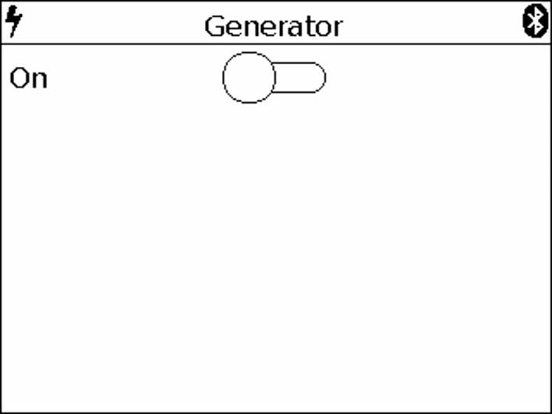
Figure 13 – Switching on the internal signal generator

7.6.2. To turn on the internal output generator, move the “slider” across the screen to the right.
On the screen will open the window for setting the frequency of the Frequency and the power of the Power of the generator output signal, as in Figure 14.
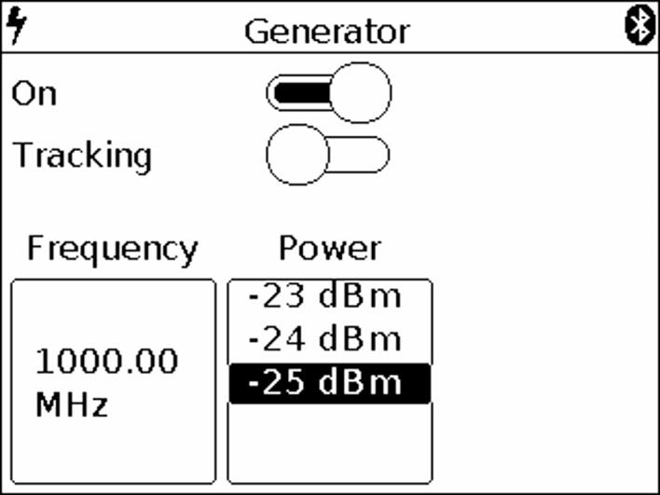
Figure 14 – Setting the frequency and power output of the generator

7.6.3. Setting the frequency of the output signal of the internal generator, Frequency, is done by entering a numeric value in the opened submenu, as in Figure 15. Enter a numeric value for the generator output frequency, between 35 and 6200 MHz, and press Enter. To delete erroneous or previously entered values, press Del. To refuse to enter a value, click Cancel. In our example, in figure 15, the output frequency of the generator is set to 1000 MHz.
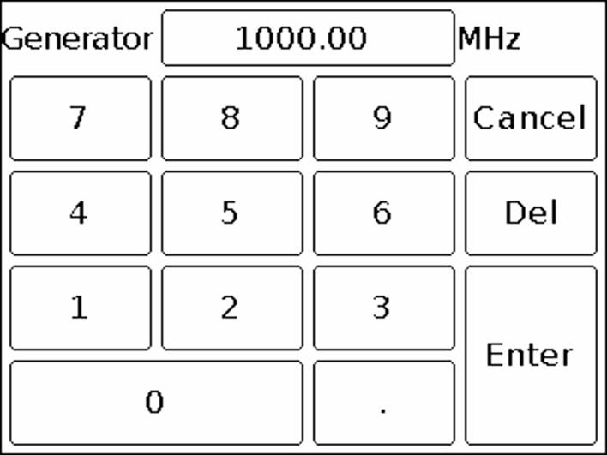
Figure 15 – Entering the numerical value of the frequency of the output signal of the generator

7.6.4. Depending on the equipment to which the generator output signal is applied, set the signal power value in the range from -15 to -25 dBm. Setting the parameter is performed by “scrolling” the values to the fixed selection area (Figure 14).
7.6.5. To determine the amplitude-frequency characteristic and measure the standing wave ratio, move the “slider” to the right opposite the Tracking parameter (Figure 14). The setup submenu appears as shown in Figure 16.
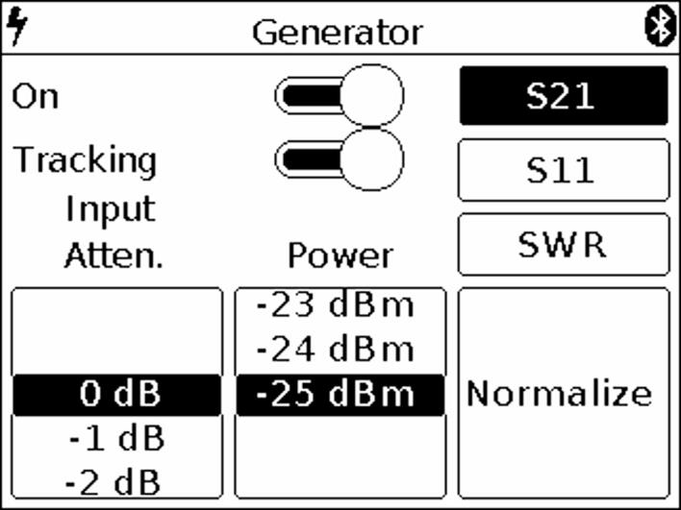
Figure 16 Enabling the mode of determining the amplitude-frequency characteristic

7.6.6. Set the desired attenuation level of the Input Atten attenuator, from 0 to -30 dB. Setting the parameter is performed by “scrolling” the values to the fixed selection area (Figure 16).
Attention! The use of small values of the input attenuator requires special care, since a signal exceeding 10 dBm can damage the input circuit of the device!
Note. Use external attenuators if necessary.
7.6.7. To determine the amplitude-frequency characteristic of the equipment under test, select the S21 mode, as shown in Figure 17. On the screen below the grid, the display of the S21 mode and the warning UNCAL (not calibrated) appear in the information box.
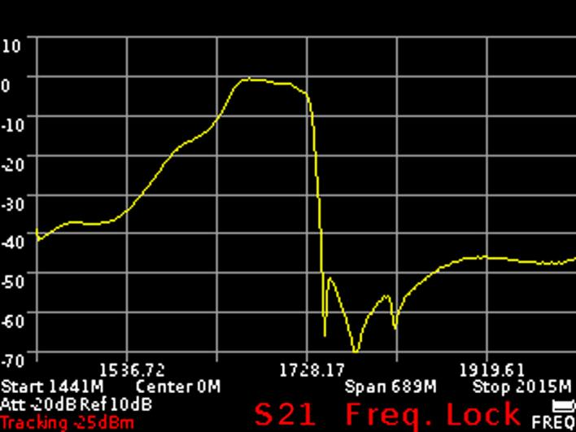
Figure 17 Determination of the amplitude-frequency characteristics of the equipment under test
Note. When determining the frequency response of active and passive devices, it is recommended to use cables with a high screening coefficient. This will ensure minimization of the parasitic transmission of electromagnetic energy from one port of the device to another port.
To reduce the influence of connecting wires and connectors on the measurement results, it is necessary to normalize Normalize the test circuit, without the test equipment. To do this, connect the output of the signal generator (1) TG OUT with the antenna input (2) RF IN of the device between the connectors (cables), which will then be used to connect to the measured device and press the command Normalize. When this operation is completed, the background of the Normalize command will turn yellow to confirm the completion of the normalize operation. To cancel normalization, click Normalize again. The command background will return to the original menu background color.
On the screen under the grid in the information label will display the mode S21 and the message Freq. Lock (frequency cannot change) (Figure 17)

Note. After normalization, the setting of the frequency span of the generator output signal and analyzer are inaccessible. Set the frequency range of the generator output signal and analyzer before normalization.
Without turning off the device, turn on the equipment under test in the circuit. The instrument will display a graph of the amplitude-frequency characteristics of the equipment under test in a given frequency range.
Note. When changing the elements in the circuit to which the tested equipment is connected, normalization should be carried out anew.
Measurement of the frequency response of active devices with known power characteristics.
To measure the frequency response of active devices, such as antenna amplifiers, with known power characteristics, it is necessary to set the signal power of the generator and the level of signal attenuation by the input attenuator so that the signal level from the internal oscillator of the device, before the normalization operation was at-50-60 dBm.
Note. A lower signal level will lead to increased noise and non-linearity of the measured signal.
After installation, perform a normalization and measure the frequency response of the active device.
Measurement of the frequency response of active devices with unknown power characteristics.
Set the minimum output power of the internal generator and the maximum attenuation value of the input attenuator of the instrument receiver. If necessary, add an additional external attenuator. Perform the normalization operation and connect the test device to the circuit. If necessary, reduce the attenuation level of the attenuator.
Note. When changing the external attenuator, perform the normalization operation again.
Attention! If the input signal level is greatly exceeded, a warning message Dynamic range exceeded appears on the screen of the device. In this case, the input level cannot be displayed correctly. In this case, it is necessary to increase the level of signal attenuation by external attenuators.
Attention! The use of small values of the input attenuator requires special attention, since a signal exceeding 10 dBm can damage the input circuit of the device!
7.6.7. To exit the menu of setting the frequency and output power of the generator, press the «MENU».

Setting parameters and measuring the reflection coefficient S11
7.7.1. To measure the reflection coefficient, it is necessary to select the S11 mode (Figure 18).
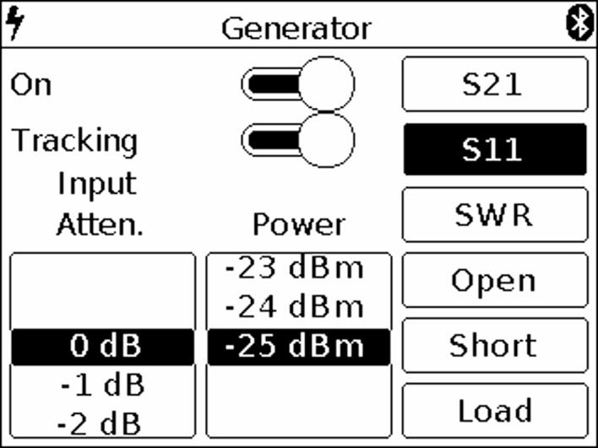
Figure 18 Turning on S11 mode

Note. The reflection coefficient S11 will be displayed in a logarithmic grid with vertical axis in dB. The horizontal axis displays the specified frequency range of the signal.
7.7.2. Set the desired level of attenuation of the input attenuator Input Atten, in the range from 0 to -30 dB. Setting the parameter is performed by “scrolling” the values to the fixed selected area.
Attention! The use of small values of the input attenuator requires special attention, since a signal exceeding 10 dBm can damage the input circuit of the device!
Note. Use external attenuators if necessary.
7.7.3. Depending on the equipment to which the generator output signal is applied, set the signal power value in the range from -15 to -25 dBm. Setting the parameter is performed by “scrolling” the values to a fixed selected area.

Note. To measure the reflection coefficient S11, it is necessary to use a directional coupler or measuring bridge at the appropriate frequency range (not included in the package). In our example in figure 19, the KROKS KSB 2700 measuring bridge is specifically designed for use with ARINST spectrum analyzers.
7.7.4. Select the mode S11 in which you want to measure, as shown in figure 18. On the screen under the grid, the information label will display the mode S11 and the warning UNCAL (not calibrated).
7.7.5. To reduce the influence of connecting wires and connectors on the measurement results, it is necessary to calibrate.
Note. It is allowed to perform calibration once for modes S11 and SWR, provided that the connectors and cables of the circuit under test do not change.
Connect the output of the signal generator (1) TG OUT of the device to the input of the measuring bridge TO TG OUT according to the wiring diagram in figure 19.

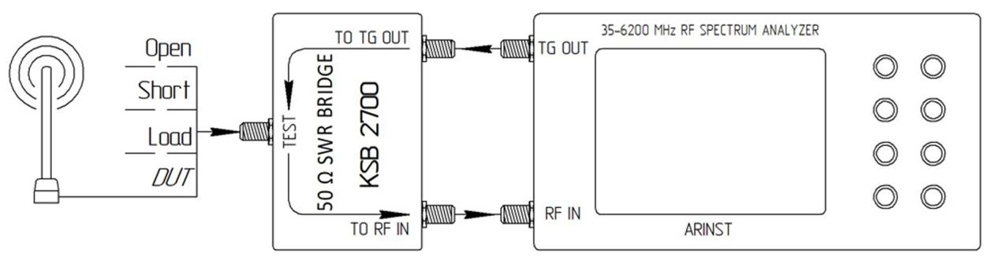
Figure 19 Connecting the measuring bridge to the spectrum analyzer
Designations in Figure 19:
TG OUT Signal generator output
Open OPEN calibration standart
RF IN Antenna input
Short SHORT calibration standart
TO TG OUT Measuring bridge input
Load LOAD calibration standart
TO RF IN Measuring bridge output
DUT Device under test
TEST Measuring port
Connect the return signal from the measuring bridge port TO RF IN to the antenna input of the device (2) RF IN.
Connect in series the loads from the standard set of calibration loads (not included in the package) to the input of the directional measuring bridge TEST:
• Open standart and press the Open command on the screen;
• Short standart, and press the Short command on the screen;
• Load standart and click Load command.
After calibration, the background of the Open, Short and Load commands will turn yellow. To cancel calibration, again click on one of the commands Open, Short and Load. The yellow background of the command changes to the original background color of the menu.
On the screen under the grid in the information label will display the mode S11 and the message Freq. Lock (frequency cannot be changed) (figure 20). Connect the test equipment (DUT) to the port TEST of the measuring bridge and measure the reflectance.
Note. After calibration, the setting of the frequency range at which the reflection coefficient is investigated is unavailable in S11 mode. Set the frequency range of the signal under study before calibration.
Note. When connecting other connectors and cables, it is necessary to re-calibrate.

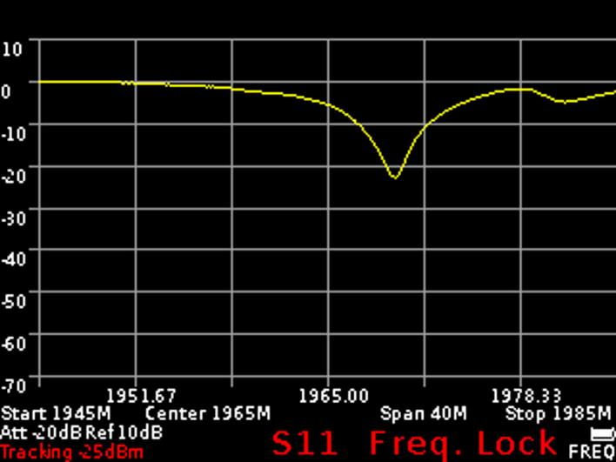
Figure 20 Display of the reflection coefficient graph
7.7.6. To exit the reflection measurement menu S11, press the «MENU».

Setting parameters and measuring the standing wave ratio SWR
7.8.1 To measure the standing wave ratio, you must select the SWR mode (Figure 21). The standing wave ratio is measured in SWR mode. The graph will be displayed with the vertical axis as a numerical standing wave ratio. The horizontal axis shows the specified frequency range of the signal.
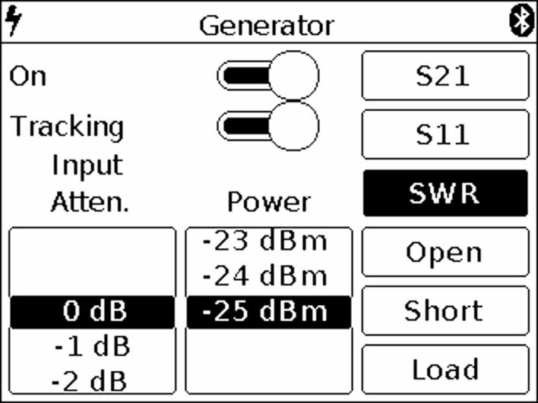
Figure 21 Enabling SWR mode
7.8.2. Set the desired level of attenuation of the input attenuator Input Atten in the range of 0 to -30 dB. Setting the parameter is performed by “scrolling” the values to the fixed selected area.
Attention! The use of small values of the input attenuator requires special attention, since a signal exceeding 10 dBm can damage the input circuit of the device!
Note. Use external attenuators if necessary.
7.8.3. Depending on the equipment to which the generator output signal is applied, set the signal power value in the range from -15 to -25 dBm. Setting the parameter is performed by “scrolling” the values to a fixed selected area.
Note. To measure the standing wave ratio, you must use a directional coupler or measuring bridge (not included in the package). In our example in figure 19, the KROKS KSB 2700 measuring bridge is specifically designed for use with ARINST spectrum analyzers.
7.8.4. Select the SWR mode in which you want to measure, as shown in figure 21. On the screen under the grid, the information label will display the SWR mode and the warning UNCAL (not calibrated).
7.8.5. To reduce the influence of connecting cables and connectors on the measurement results, it is necessary to calibrate.
Note. It is allowed to perform the calibration once for the SWR and S11 modes, provided that the connectors and cables of the circuit under test do not change.
Connect the output of the signal generator (1) TG OUT of the device to the input of the directional measuring bridge TO TG OUT according to the wiring diagram in figure 19. Output of the reflected signal from the measuring bridge port TO RF IN connect to the antenna input of the device (2) RF IN.
Connect in series the loads from the standard set of calibration loads (not included in the package) to the input of the measuring bridge TEST:
• Open standart and press the Open command on the screen;
• Short standart, and press the Short command on the screen;
• Load standart and click Load command.
After calibration, the background of the Open, Short and Load commands will turn yellow. To cancel calibration, again click on one of the commands Open, Short and Load. The yellow background of the command changes to the original background color of the menu.
On the screen under the grid in the information label will display the SWR mode and the message Freq. Lock (frequency cannot be changed) (figure 22). Connect the test equipment (DUT) to the TEST port of the measuring bridge and measure the standing wave ratio.
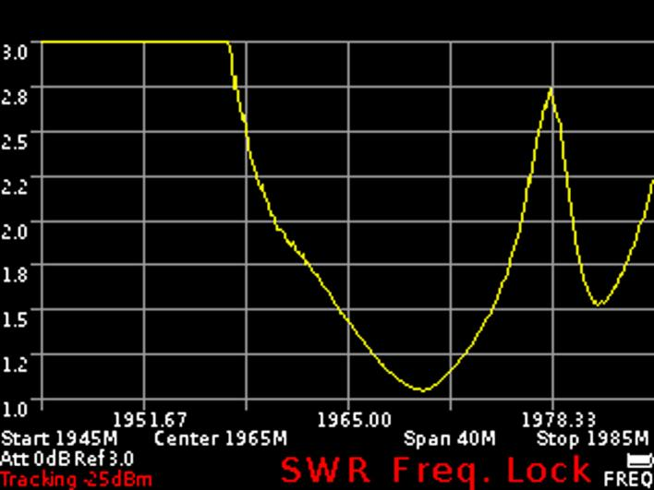
Figure 22 Displaying the standing wave ratio in the SWR mode

Note. After calibration, setting the frequency range and amplitude values of the test signal in SWR mode becomes unavailable. Set the frequency range and amplitude values of the test signal before calibration.
Note. When connecting other connectors and cables, it is necessary to re-calibrate.

7.8.6. To exit from the menu for measuring the standing wave ratio SWR, press the «MENU».

Custom settings menu
7.9.1. To save the spectrum scan settings (frequency range, attenuator value), settings for equipment testing (frequency and power of the internal signal generator), etc., enter the main menu by pressing the «MENU» (Figure 6) and select subsection Presets. A menu of custom settings will appear on the screen, as in figure 23.
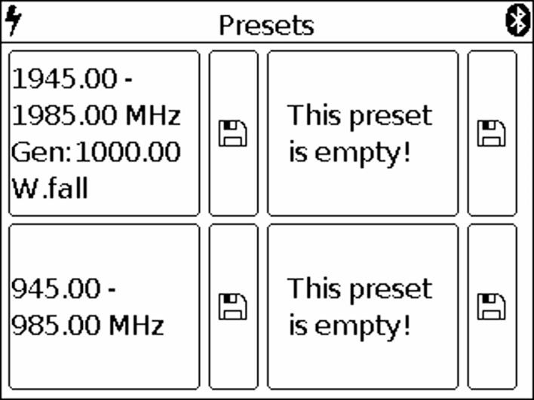
Figure 23 Custom settings menu

7.9.2. The device allows you to save up to four user settings. To save the settings, click on the image of the floppy disk. A display of your settings will appear in the field to the left of the diskette (the range of the scanned frequencies, the frequency of the internal signal generator, settings for measuring the frequency response and SWR).
7.9.3. To save the new settings, click on the image of the floppy disk, near the field without settings. If all four fields are occupied by user settings, overwrite by clicking on the image of the diskette near the outdated or unnecessary settings.
7.9.4. To activate the saved mode with custom settings, click on the field with the corresponding characteristics.
7.9.5. To enter the main menu, press the«MENU».

